HESI A2 Entrance exam: Students FAQ and How to prepare
*What is the HESI A2 exam?
The HESI Admission Assessment, commonly referred to as the HESI A2 exam or HESI Entrance Exam, is a proctored test used by DMS and RAD programs to evaluate applicants as part of their admissions process. Many pre-licensure require the HESI A2 for admission. This is a timed assessment exam that is administered and scored in a consistent manner across all test-takers. It is designed to measure specific knowledge, skills, or abilities according to uniform criteria. Overall, standardized tests aim to provide a reliable and valid assessment of abilities or knowledge, ensuring fairness and consistency in evaluation.
Additionally, some schools may administer further HESI exams throughout the program and before graduation to assist students in preparing for board examinations and to assess their grasp of specific skills.
*What is on the HESI A2 Exam?
Students applying to the RAD and DMS programs will be required to take Anatomy and Physiology, Math, Critical Thinking, Learning Style, and Personality Style portions of the exam.

- Anatomy & Physiology: 30-item exam. Provides coverage of general terminology and anatomical structures and systems. Time: 25 minutes.
- Math: 55-item exam. Focuses on math skills needed for health care fields, including basic addition, subtraction, multiplication, fractions, decimals, ratio and proportion, household measures, and general math facts that are useful, for example, when calculating drug dosages and solutions. Time: 50 minutes.
- Critical Thinking: 25-item exam. Assesses your ability to think critically in situations commonly encountered in the healthcare setting. Each exam item receives its own score. Time: 30 minutes.
- Learning Styles: 14-item assessment. This helps to assist the student and advisor in knowing what environment the student learns best in. Time: 15 minutes.
- Personality Style: 15-item assessment. Assessment of personality related to preferred learning style. Students receive a printout with study tips based on their learning style and personality profile. Time: 15 minutes.
*How can I prepare for the HESI A2?
Before taking the entrance exam, it is highly recommended that students prepare thoroughly. Although there is no specific passing score, keep in mind that the programs are highly competitive; a higher score will improve your standing in the ranking process. The HESI score will contribute 25% to your overall ranking.
Several resources are available to help you prepare for the exam. Elsevier's "HESI Admission Assessment Exam Review" book (ISBN# 978-0-443-11409-0) is available at each campus's resource center, or you can purchase it from a vendor if you prefer. Additionally, your advisor can provide a study guide for the Math and A&P sections. The other sections are more reaction-based, and we are looking for authentic responses.
*How many attempts does the student have and what is the cost for the exam?
Students can take the HESI A2 exam up to twice, with both attempts needing to occur within two years of applying for the program. If a student is not satisfied with their first attempt, they can choose to retake the exam. Retaking just one section of the exam also counts as a repeat attempt. South College covers the cost of the initial attempt, but students are responsible for the fee of any subsequent attempts.
Students who are seeking readmission into an imaging cohort and were not initially responsible for taking the HESI Admission Assessment, will have to take the exam to become eligible for readmittance. Please check with the Program Director if you are unsure if you need to take the exam.
- Paying for your 2nd attempt: -
To make a payment for your HESI A2 exam, please reference the HESI e-Commerce Student Payment Notification email distributed by your instructor. This email contains a link that will prompt you to complete the following steps:
NOTE: If you did not receive this email, please contact your instructor.
  - 1. Verify your payment ID, program, payment description, payment date, and price in sections 1 and 2 a. You can only make one payment per payment ID
  - 2. Enter the Billing information in section 3 a. Please use the billing name and address associated to the credit card used for payment
        - 3. After payment confirmation, a proof of payment receipt will be displayed and stored in your account under Payment History **Your payment receipt will reflect the name associated to the Evolve Username, not the name on the credit card used for payment
*Once I am ready for the exam, how do I schedule a time to complete it?
Once students feel they are ready for the exam, they will work with their advisor to schedule a time to complete. (can customize based on your campus’ scheduling process)
*Preparing for TEST DAY:
1. Prior to test day, students will need to create an account with Elsevier https://evolve.elsevier.com/
a. If you already have an Evolve account, click “Sign in” in the upper right corner and use your existing credentials to log in
b. If you do not have an Evolve account, click “Sign in” in the top right corner, then “Create account”, and follow the instructions to create your new Evolve account. You need to create an account using your South College student email.
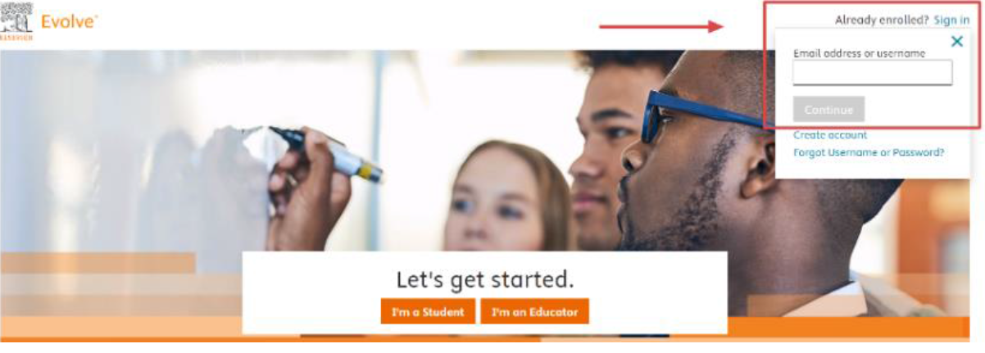
2. On the Evolve homepage, navigate to the “HESI Secured Exams” section in the lower right corner
3. Click the “Register for Results and Remediation” link, then the “Register” button
4. Click “Proceed to Checkout/Redeem” in the lower right corner to complete the checkout process

*Taking the Test
Prior to test day it is important that the student create the Elsevier account and complete the compatibility check for the non-nursing programs on the HESiiNet.com website on the device they plan to take the exam on. If their device is not compatible, they will need to arrange to check out a device from the resource center on campus prior to test time. Please ensure that you bring the device that you run the compatibility check on to campus for test day.
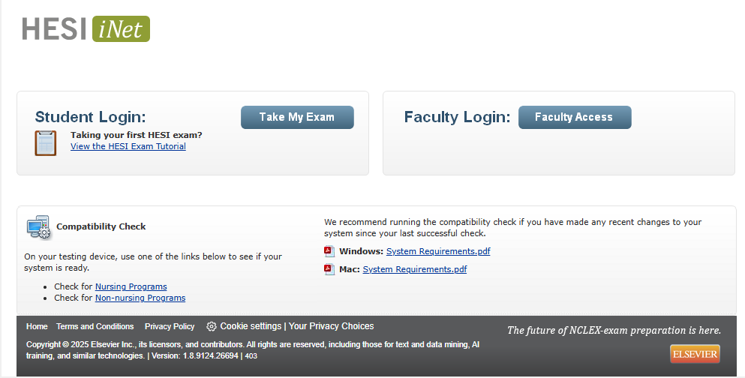
If you have received approved accommodations from the school, please submit the official approval letter to the exam administrator or your advisor the day that you schedule your exam. These accommodations can be applied to the HESI exam, but it is important to inform the exam administrator in advance so that the necessary arrangements can be made. Upon arrival at your designated testing area, please set up your space accordingly and follow the instructions below if you have not created an account prior to test day.
1. Login using your Evolve credentials using a personal computer or iPad
a. If you are using a personal computer:
i. Navigate to the HESI iNet homepage https://hesiinet.elsevier.com
ii. Enter the access code provided by your proctor
iii. Follow the on-screen instructions to download the HESI Secure Browser
b. If you are using an iPad:
i. Navigate to the Apple App Store and download the HESI Secure Browser
ii. Open the app
iii. Enter the access code provided by your instructor
NOTE: If you are using a Mac, a “Device is setup” message will appear upon successful installation.
2. As you proceed with your testing, be sure to complete all required exams
3. Depending on the exam settings, there may be PDFs of scores available soon after each module is completed, plus a summary report that collates all completed modules
4. A calculator is built into the testing software and you will NOT be permitted to use your device.
NOTE: If you exit the exam and leave the HESI Secure Browser, you may not be able to re-enter the exam without assistance from the proctor. If the allotted exam time has expired, you may receive a timeout message and be disconnected from the exam.

*Score Reporting and Remediation
Once you complete the exam, your score will be reported to the appropriate people. This score will be used for the ranking process for the imaging programs. You can access your score and exam remediation using the following instructions. This remediation will help you review the items you were strong in and areas for improvement.
  - 1. Log into your Evolve account: https://evolve.elsevier.com/
    - a. In your My Evolve list, locate the HESI Assessment resource and click “Student Access”
    - 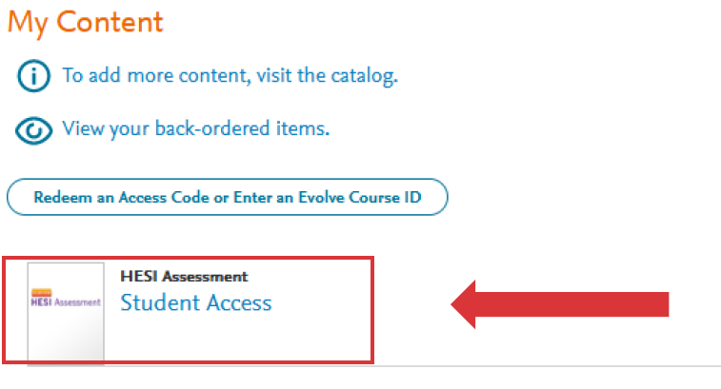
    - 2. The Exam History section in your Student Access area will contain a list of reports for previous exams where you can easily view your scores
    - 3. Click the hyperlink for an exam to view more details about your score, including remediation a. Click the small “+” sign next the report link to expand the report and see more information about each module
    - 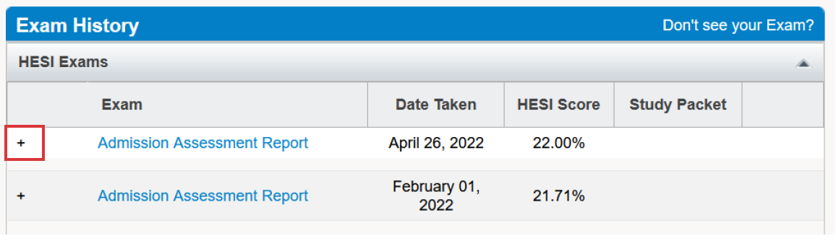
    - 4. In the far-right column, click the “View Results” for the corresponding exam you would like to review
      - a. Use this section to see more detailed scoring about this specific exam section instead of a summary
    - NOTE: The Study Packet column may list zero items, but you can still see the detailed results.
    - 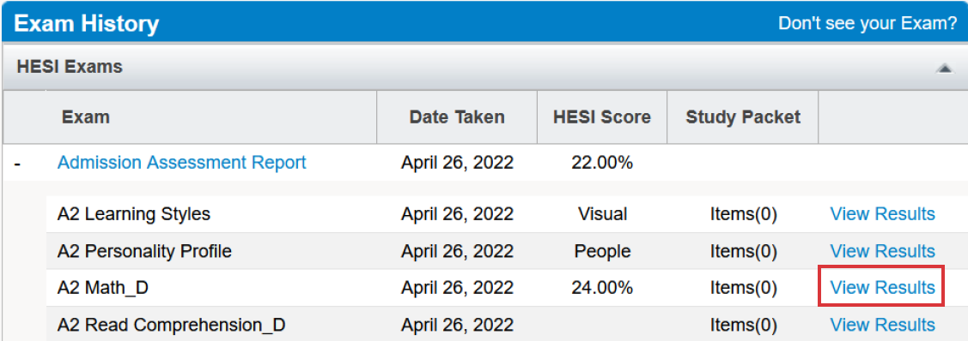
    - 5. In the Review Materials column, click the blue “View Materials” button to access remediation content
    - 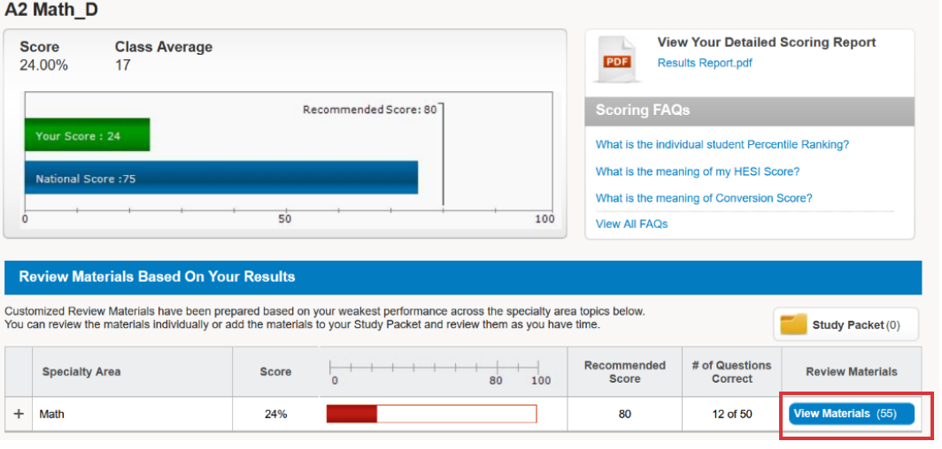
    - 6. When reviewing materials, you can add remediation content to a study packet or select pieces of content to review
a. To add remediation content to your Study Packet, select the corresponding checkbox(es) in the “Add to Study Packet” column, then click the green “Add to Study Packet” button above
    - NOTE: Remediation content is only available online
  - 