HESI Math Study Guide

**General Information**

You thought you were going into a science-related profession, so why are you being asked to do math? Love it or hate it, nurses use mathematics for a number of calculations in nearly every area of their job. From Urology to Gastroenterology, nurses use math to conduct dimensional analysis, read and analyze patient charts, and carry out day-to-day functions.

For this test, you *will* have access to a very simple, **on-screen calculator** for the math questions. You may *not* bring and/or use your own calculator, so don’t rely on being able to do much beyond the four basic operations (add, subtract, multiply, and divide) on a calculator. This test should not require you to do anything beyond those, anyway, though.

Here are some basic math concepts you should understand before taking the mathematics section of the HESI exam.

**Computation with Whole Numbers**

Computation with whole numbers includes **basic operations** such as **addition**, **subtraction**, **multiplication**, and **division**. It relies upon the concept of **place value** in our number system. You might remember the charts from school showing how each digit in a number, for example 7,654,321, has a place value, as shown in the following chart:



When reading this number aloud, you would say, “Seven million, six hundred fifty-four thousand, three hundred and twenty-one.” This system also allows us to borrow and carry digits when computing addition and subtraction because our number system relies upon **powers of ten** in what is called a **base ten system**.

For example, the number 45 can be understood to be 4 tens and 5 ones, or 45 ones. Similarly, the number 7,200 can be called 72 hundreds or 7 thousands and 2 hundreds.

*Note: In this guide, we use the terms “borrow” and “carry.” In modern math courses, both of these are covered under the term “regroup.” The words mean the same.*

**Addition**

Addition is the most basic computation we can do with whole numbers. It is the process of **combining two numbers into one**. Traditionally, the easiest way to do this is by writing the two numbers in **column format**, or vertically, so that each place value is aligned, and adding **first the ones values**, then tens values, then hundreds, and so on until the problem is complete. In other words, when setting up your problem, be sure to **align** it so that the rightmost numbers―the ones values―are on top of each other.

*Example:*

*Susana and Tim are coworkers at a hospital. They each purchased boxes of bandages for the hospital dispensary without talking to each other. Susana bought 5,800 boxes while Tim purchased 3,500 boxes. How many boxes did they wind up with, in total?*

In this problem, the two numbers we are going to add together are 5,800 and 3,500. We write them in column format, making sure the ones place values are aligned, and then add down.

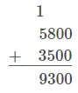

Notice how when we add the hundreds column, 8 hundreds plus 5 hundreds is 13 hundreds or 1 thousand and 3 hundreds. We put the 3 down as our answer for the hundreds column and carry the 1 over into the thousands column. Our final answer is 9,300 boxes of bandages.

*Example:*

*Cameron has $8,726,904 in his bank account. At the end of the next week, his paycheck is $791 after taxes. How much money is in his bank account after he deposits the check?*

Again, we want to make sure the ones values sit on top of each other when we set up this problem.

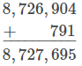

Cameron has $8,727,695 in his account after his paycheck is deposited.

**Subtraction**

Subtraction is the idea of finding the **difference between two numbers**. Much like addition, we traditionally solve subtraction problems by **aligning** the ones position into a column and taking away some number from the top. If the bottom digit is larger than the top digit, we will have to borrow from the next column. Let’s look at an example.

*Example:*

*Jason has 174 pounds of apples for sale at his farmer’s market stall. He sells 48 pounds by the end of the day. How many pounds of apples does he have left for sale the next day?*

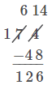

Jason has 126 pounds of apples left to sell. Since we can’t subtract 8 from 4, we have to borrow from the tens column. The 7 tens is the same as 6 tens and 10 ones (really!). The 10 ones are moved over to the ones column to join the 4 ones for a total of 14 ones. We leave the 6 tens in the tens column. From here we can easily subtract down.

Note that for subtraction problems, the **order of the numbers matters**. We start with 174 pounds, and then take away 48 pounds. Pay attention to what number you *start with* in a word problem and *what is subtracted* from it.

*Example:*

*A bag of saline solution originally containing 975 mL has delivered 190 mL to the patient. How much saline is left in the bag?*

The original amount of saline we started with is 975 mL, so that number will be on top. We subtract 190 mL, so that will be placed on the bottom as we set up the subtraction problem.



Since we cannot take 9 tens from 7 tens, we have to borrow from the 9 (sometimes called “regrouping”) in the hundreds column. The 9 hundreds becomes 8 hundreds and 10 tens. The 10 tens combine with our 7 tens to become 17 tens. Now we can subtract down each column. The amount of saline left in the bag is 785 mL.

**Multiplication**

Multiplication is a shortcut for **repeated addition**. We can look at this visually with the following table:

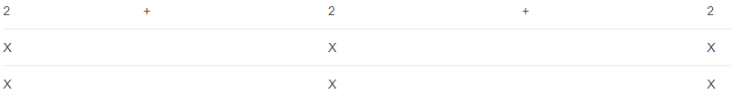

This table shows a familiar multiplication problem, 3×2. If we repeatedly add by twos, we find that 2 + 2 + 2 = 6 or, in other words, 2, added 3 times, equals 6. This is also the basis for skip counting. An example of skip counting by twos is in the common cheer heard at sports rallies: “Two, four, six, eight, who do we appreciate?”

This is nice for smaller, familiar multiplication problems. What happens when you have to multiply large numbers, like 360 times 21? Then, a column format similar to what we used for addition and subtraction is helpful. It’s easiest to place the larger number on top for your calculations.

The first step is to multiply the ones digit from the bottom number by each digit of the top number, working from right (the ones column) to left.

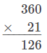

In this particular multiplication problem, we start by multiplying the 1 in 21 by 360, digit by digit, from right to left.

Our next step is to multiply the tens digit from the bottom number by the top number. Before we do that, we’re going to insert a **placeholder**, 0, to show that the 2 in 21 indicates we’re multiplying by 2 tens.



The final step is to add the products, or answers to a multiplication problem, together. It may help to think of this as though the first step is multiplying 360 by 1 and the second step is multiplying 360 by 20. Since multiplication is repeated addition, the final step to find the answer in 360 times 21 is to add the two previous steps together.

Note also that we had to carry a one over to the hundreds column after multiplying 2 by 6 to get 12. This carried number is then added to our answer when we multiply the 3 from 360 by the 2 in 21.

Before we look at a word problem example, ask yourself, “How does the place value system help us do long multiplication?”

*Example:*

*Jada works at a popular mobile phone and technology store. She receives 245 boxes each filled with 27 brand-new phones to be released for sale the next week. How many phones do they have in stock total?*

One way to visualize this problem is to picture one box that you open up to see 27 phones packed inside. As you open up each new box, you have to add another 27 phones to your inventory. But with 245 boxes, that can take quite a while. So we’re going to work it out in column format.

We put the larger number, 245, on top. Step one is to multiply the ones column from the bottom number, 7, by 245.



Again, we have to carry over a number after multiplying 5 by 7 and 4 by 7.

The next step is to multiply the tens column of the bottom number, 2, by 245. Don’t forget your placeholder zero, because the 2 in 27 is really 2 *tens*.

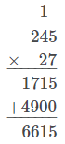

Our final step is to add 1715 + 4900. Our answer is that Jada has 6,615 shiny new phones to sell in her store.

*Another example:*

*Suppose Jada is able to sell all 6,615 of the phones. Each phone sold for $124. How much money did she take in selling the phones?*

Every time Jada sells a phone, she receives $124. But it’s hard to keep track when she sells 6,615 phones! We’re going to help her out by multiplying 6,615 by $124.

This problem is only different from our previous examples in that the bottom number, 124, has three digits instead of just two. That means that we will have to add another step where we multiply the hundreds column, 1, by 6,615. Since it is 1 hundred, we’ll have to add in two placeholder zeros.

The first step is to multiply 4 ones by 6615, as shown in the following equation:

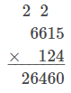

The next step is to multiply the tens column of the bottom number, 2, by 6,615. Don’t forget a placeholder zero.

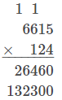

The third step is to multiply the hundreds column of the bottom number, 1, by 6,615. We use two placeholder zeros (bolded below) to show that we’re multiplying by 1 hundred.

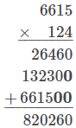

The final step is to add up the three multiplications we did. The total amount Jada collected from selling all the new phones is $820,260.

**Check with a Calculator:**

Get a calculator. Double-check the answer to the given example by following these steps:

1. Multiply 6,615 by 4.
2. Multiply 6,615 by 20.
3. Multiply 6,615 by 100.
4. Add together your answers from steps one to three. Is it the same as the answer we got above?

**Division**

If multiplication is repeated addition, then division is **repeated subtraction**. We start off with some number and what we want to know is how many times we would have to subtract another number from it until we arrive at zero. The number we start with is the **dividend**, while the number we repeatedly subtract is the **divisor**. In division problems, the answer is called the **quotient**. In other words, dividend ÷ divisor = quotient.

Again, this is easy to visualize and do with smaller numbers but when it comes to larger numbers, it’s not so practical. We have a method for this―**long division**. This looks different from addition, subtraction, and multiplication problems. Let’s take a look at an example.

*Example:*

*Alexis has 4,630 milliliters of a chemical. Each time she does an experiment, she uses 125 milliliters. How many experiments can she perform?*

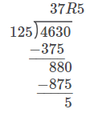

The work above shows how a long division problem works.

* The *divisor*, 125, sits outside the long division symbol, while the *dividend* resides underneath it.
* The *quotient*, as it is worked out, is placed on top of the symbol, with each of its digits corresponding to the place value of the dividend (ones values over ones values, tens values over tens values, etc.)
* The “R” indicates a **remainder**, or that the dividend is not divided by the divisor into equal parts, but that some amount remains **left over**. In this example, the remainder is 5.

In the first step for this problem, we look at how many times the divisor, 125, goes into 463 from the dividend. Why 463? That is the smallest amount that can still be divisible by 125. The number 46 is too small, while 4,630 is too large. It goes in 3 times, so we write that up top, over the last digit we included (3).

Then we multiply 1253 = 375, and write that below the dividend, aligning the digits to 463. We subtract down to find 88 remains.

The ones digit from the dividend is carried down so that we are now working with 880. How many times does 125 go into 880? It goes in evenly 7 times, so we write that above in our quotient.

Again, 1257 = 875. Subtracting 880 – 875 = 5, which is our remainder, since it is too small for 125 to be divided into it.

Thus, Alexis can do 37 experiments with 125 milliliters of chemical each, but she will have 5 milliliters left over.

*Example:*

*Manuel is a dispensary technician in a hospital. He is sorting 872 smocks from a new shipment into 16 groups evenly for each department’s use. How many smocks will each department receive and how many will be left over?*

First, identify which number is your divisor and dividend. We start with 872 smocks, so that is the dividend and goes under the long division symbol. The divisor, or how many groups we’re splitting them into evenly, is 16, and this number goes to the left of the division symbol.

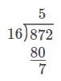

The first step is to divide 16 into 87 as many times as it can go evenly. Since this is 5, we write 5 as the greatest digit in our quotient. Since 165 = 80, we place that below the dividend and subtract. We are left with 7.

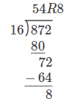

The next step is to bring down the 2. Then 72 divided by 16 is 4, which is placed in the ones place of the quotient. Since 164 = 64, we subtract that from 72 and are left with 8. Since 8 is too small to be divided by 16, that is the remainder and we have finished.

Manuel will have sixteen groups of 54 smocks evenly, but 8 smocks will be left over.

**Fractions**

Fractions are parts of numbers, or **portions of a whole**. You might remember seeing fraction sticks in school, and creating a fraction out of the number of shaded parts over how many parts there were in total. For example, below is a rectangle divided into 12 equal parts. Six of these pieces are shaded. To write a fraction for this, we put the number of shaded pieces on top for the fraction’s **numerator**, or top number, and the total number of sections on the bottom for the fractions **denominator**, or bottom number.

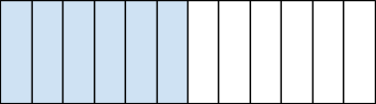

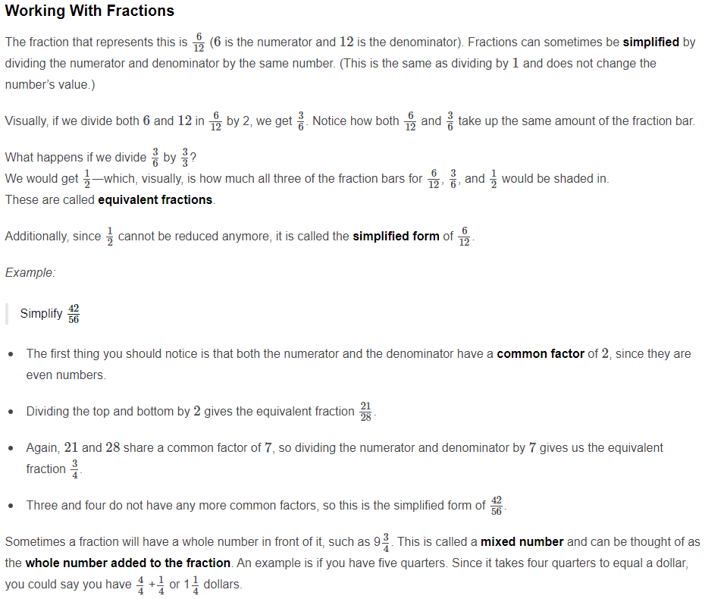

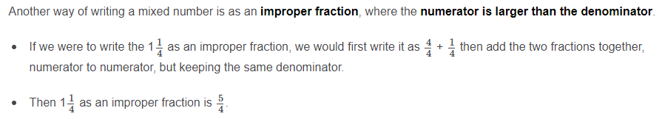

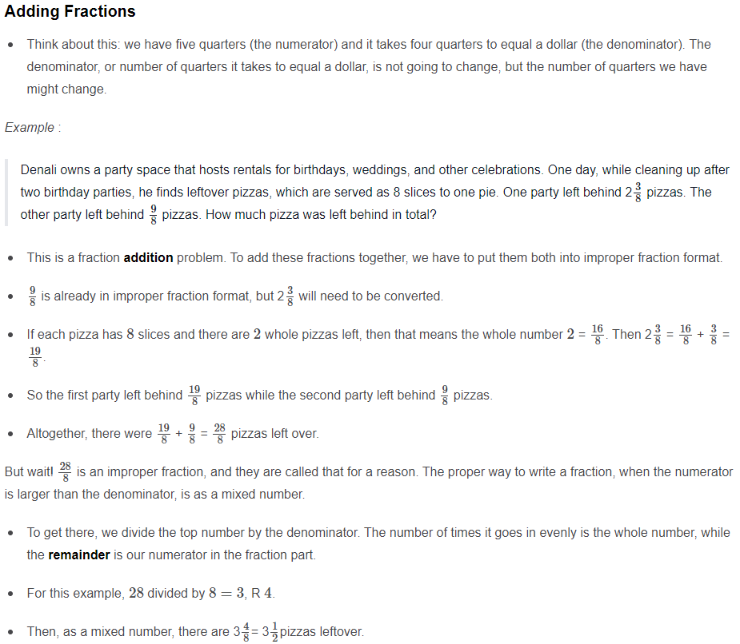

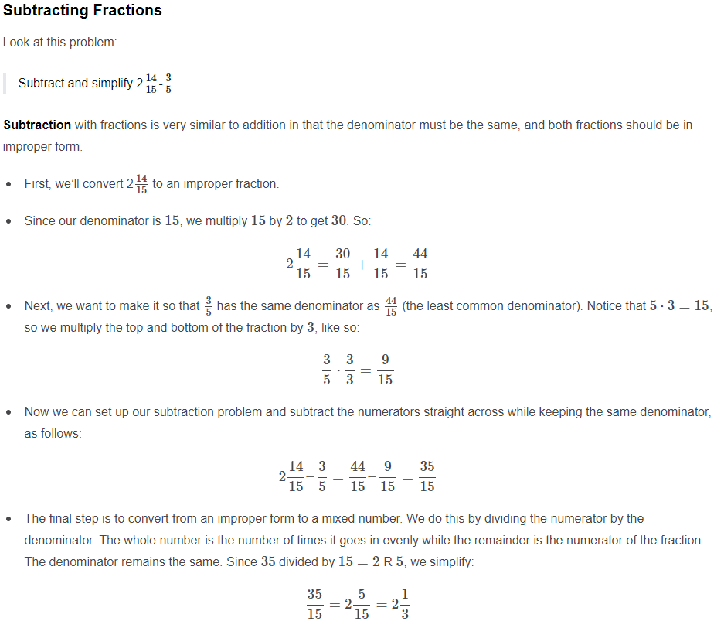

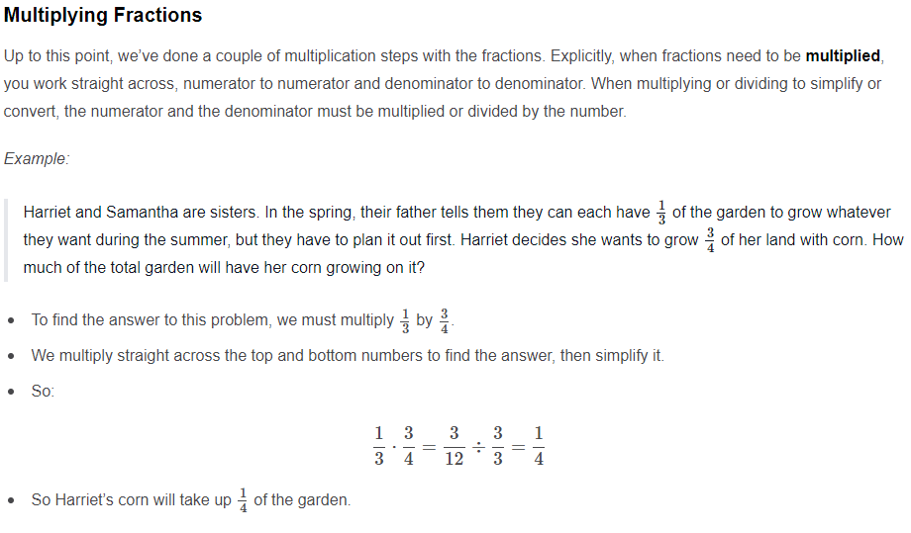

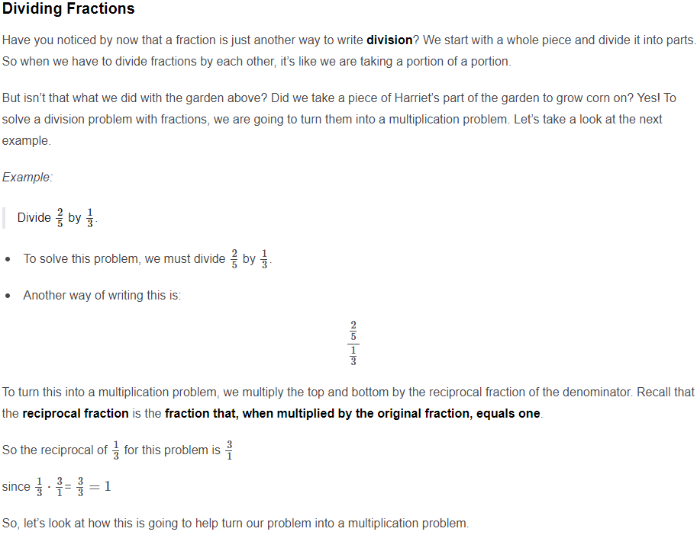

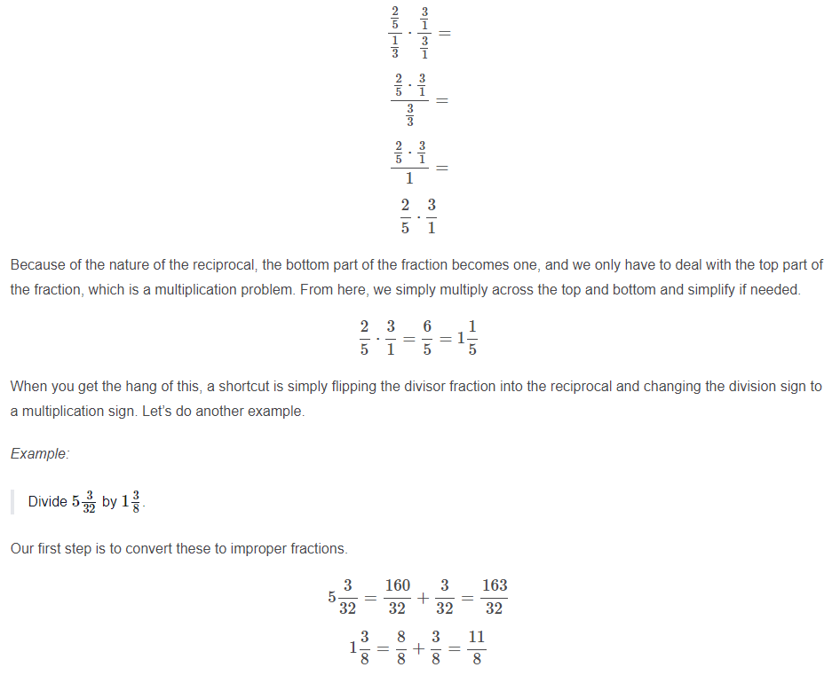

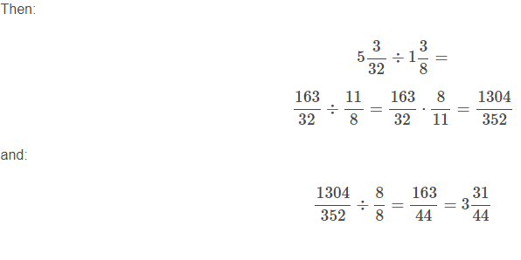

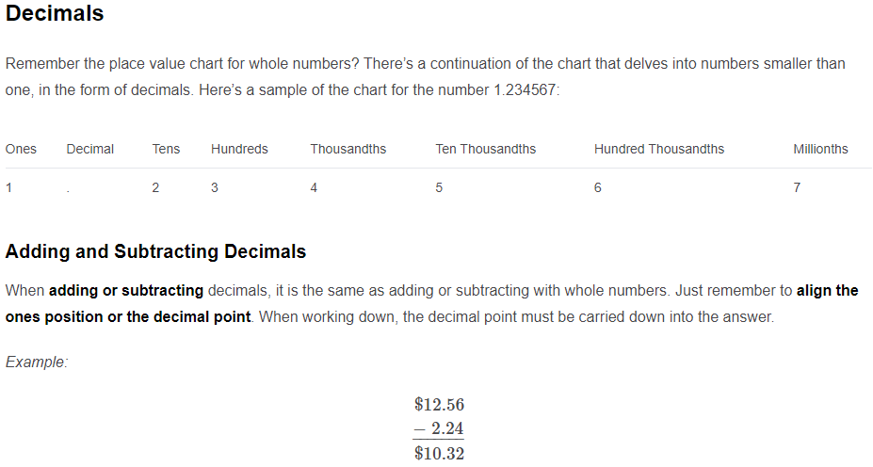

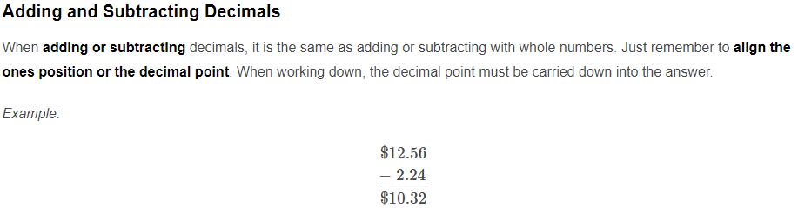

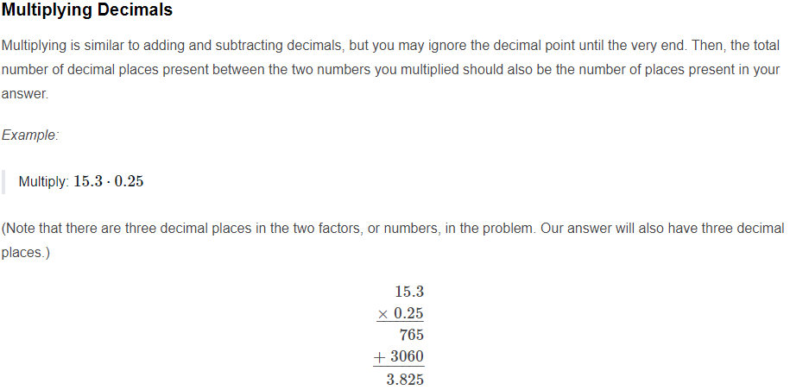

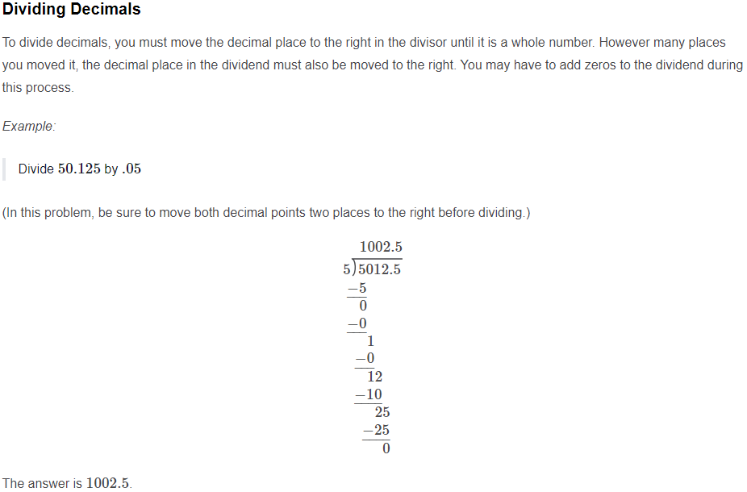

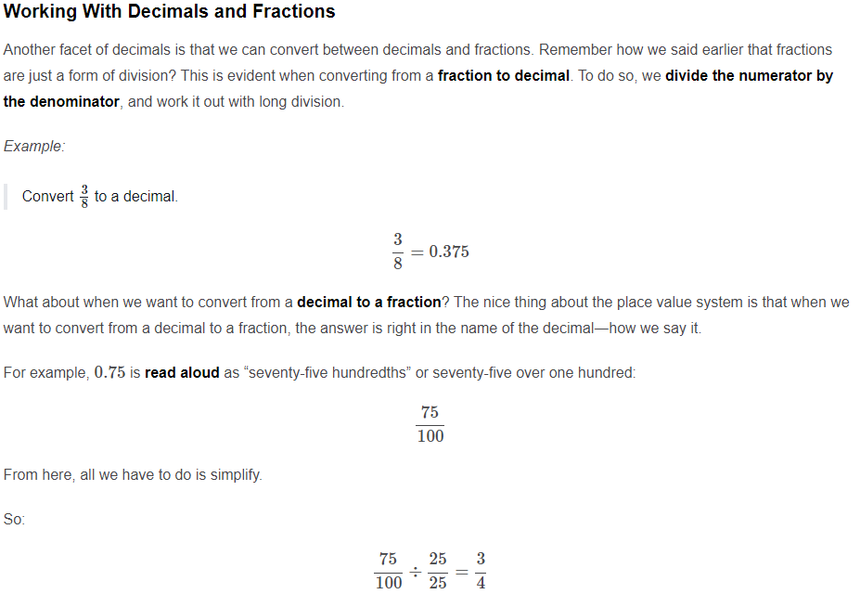

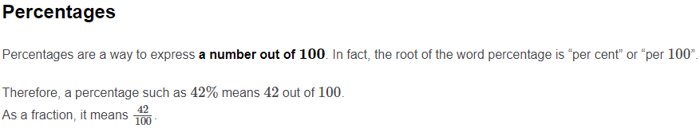

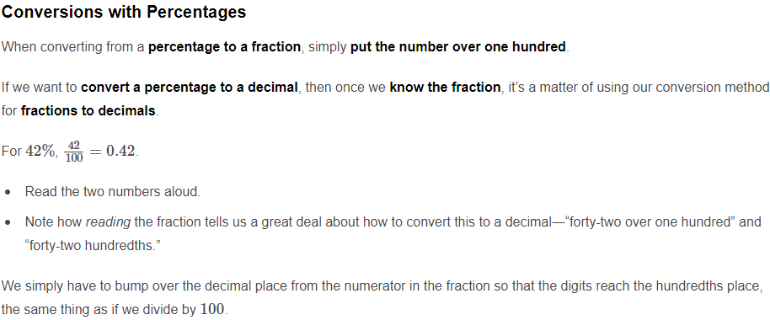

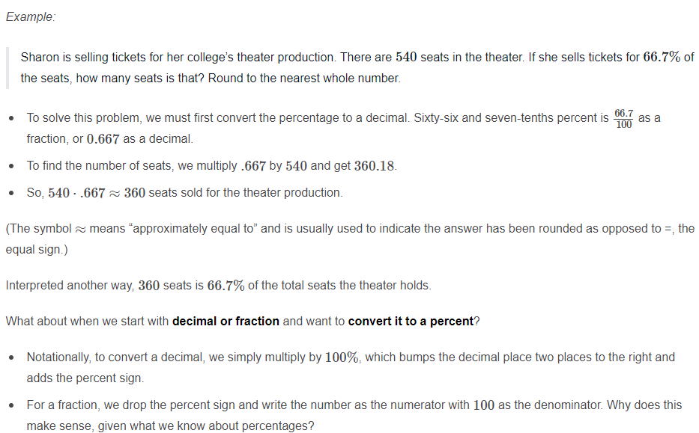

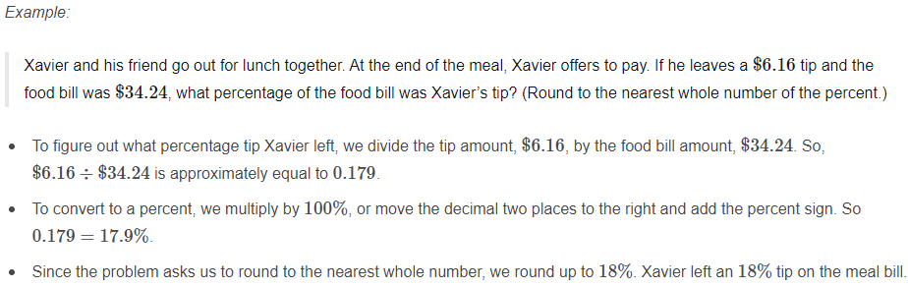

**Military Time**

Military time is a way to tell the time by looking at the hours in the day as **24 hours** rather than the standard two twelve-hour periods of a.m. (morning) and p.m. (evening). Military time starts at midnight with 0000 and continues up to 2400 (midnight again). This means less confusion if someone tells you to meet at, say 8 o’clock. In the 12-hour clock system, or civilian time, this could be in the morning or the evening. In military time, 0800 hours could only be the morning. Below is a conversion chart between the two systems.

|  |  |
| --- | --- |
| Civilian Time | Military Time |
| 12:00 am | 0000 hours |
| 1:00 am | 0100 hours |
| 12:00 pm | 1200 hours |
| 1:00 pm | 1300 hours |
| 2:00 am | 0200 hours |
| 2:00 pm | 1400 hours |
| 3:00 am | 0300 hours |
| 3:00 pm | 1500 hours |
| 4:00 am | 0400 hours |
| 4:00 pm | 1600 hours |
| 5:00 am | 0500 hours |
| 5:00 pm | 1700 hours |
| 6:00 am | 0600 hours |
| 6:00 pm | 1800 hours |
| 7:00 am | 0700 hours |
| 7:00 pm | 1900 hours |
| 8:00 am | 0800 hours |
| 8:00 pm | 2000 hours |
| 9:00 am | 0900 hours |
| 9:00 pm | 2100 hours |
| 10:00 am | 1000 hours |
| 10:00 pm | 2200 hours |
| 11:00 am | 1100 hours |
| 11:00 pm | 2300 hours |

The last two digits of the military time are reserved for the minutes, just like in civilian time, and can show from 00 to 59. To find the conversion between military and civilian time, we subtract twelve or count up from twelve. Let’s look at some examples.

*Example:*

“Tiana has to report for work at 1945 hours. What time is this in civilian time?”

The first two digits, 19, refer to the hour. If we **subtract twelve**, we’re left with 7. The minutes work the same way in both systems. So Tiana has to work at 7:45 pm.

*Example:*

Sebastian invites his friend to meet for coffee at 2:20 p.m. “What time is that in military time?” his friend asks him. How does Sebastian answer?

From 12 noon to 2 p.m. is 2 hours. So **adding 12** to 2 gives us 14 as the hour. The minutes stay the same. Sebastian wants to meet at 1420 hours.

*Example:*

Iliana is planning her day. She marks down “Workout―0545 to 0630.” In civilian time, when is Iliana working out?

Since the hours are below 1200, we know this is in the morning, and the hours and minutes are the same as in civilian time. Iliana is working out from 5:45 a.m. to 6:30 a.m.

**Roman Numerals**

*Roman numerals* form the ancient number system used in the Roman Empire. In select situations, they are still used as an alternative to the modern numeral system. Roman numerals are based on the idea of **adding**, and in special cases, **subtracting**, to represent each number. The following table provides a list of the most commonly used Roman numerals today and their meaning.

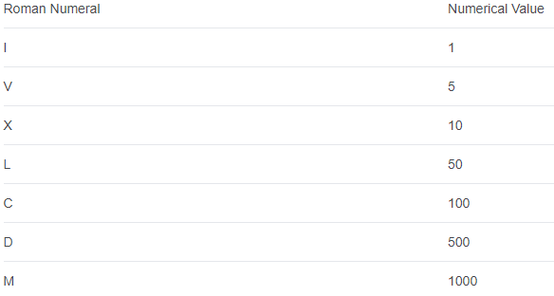

Roman numerals are written from left to right, **greatest numeral to smallest**. As you read them, add together the symbols for the numeric value.

*Example:*

Erica is visiting Rome for vacation. She sees an old building with ‘MCCLIII’ written on it. What number is this?

Looking at our reference chart, we see the first symbol, M, is 10001000. CC is 100+100100+100, L is 5050, and III is 1+1+11+1+1. Adding this together shows that:

1000+100+100+50+1+1+1=12531000+100+100+50+1+1+1=1253 is the number on the building

There are a few special cases where instead of adding, we subtract to find the meaning of the Roman numeral. These special cases occur when we want to avoid stringing four of the same symbol together (like IIII for 4 or VIIII for 9). Instead, we use one of the symbols for a power of ten (I, X, C, M) and place it before a symbol with a greater numeric value.

An example of the first time this would occur is for the value of four. This is written as IV, or “5 minus 1.” The next time this occurs is for the number nine, IX, or “10 minus 1.” Forty is denoted by XL, or “50 minus 10,” while ninety is XC, or “100 minus 10.”

*Example:*

Jerome is in class and wants to toss a note inconspicuously to let his friend know which anniversary of a big football game finale is coming up. He knows it’s going to be the 459th year the game has been held. How would he write this number in Roman numerals?

* First, we break up the number by place value. Written this way, 459 becomes 400 + 50 + 9 or (500–100) + 50 + (10–1).
* In Roman numerals, we write this as CDLIX. So Jerome would write “FOOTBALL CDLIX!!!” in his note to his friend.

**Basic Measurement Conversions**

Any **measurement** of an object will be taken in a certain **unit**. Whether it’s the volume of a unit of blood in milliliters, the height of a person in inches, their weight in pounds, or medicine in grams, there is a unit attached to it so that we have an idea of exactly how much that measurement means.

Very often, however, the unit the measurement is given in is not the unit we need to know. In that case, we must convert to a different unit. The following table provides some common **conversion factors** or measurements that are equivalent and used to calculate conversions.

1 gallon = 4 quarts

1 quart = 2 pints

1 pint = 2 cups

1 cup = 8 ounces

1 cup = 16 tablespoons

1 gallon = 3.78541 liters

1 pound = 453.592 grams

1 ounce = 28.3495 grams

1 kilogram = 2.20462 pounds

1 kilometer = 0.621371 miles

1 mile = 5280 feet

1 mile/hour = 1.60934 kilometers/hour

1 inch = 2.54 centimeters

1 kilometer = 1000 meters

1 meter = 100 centimeters

1 meter = 1000 millimeters

1 liter = 1000 milliliters

1 kilogram = 1000 grams

1 gram = 1000 milligrams

1 year = 365 days

1 year = 52 weeks

1 day = 24 hours

1 hour = 60 minutes

1 minute = 60 seconds

Some of these conversion factors might look familiar, while others are new. Usually, people find that the more often they use a conversion factor, the easier it is to recall. But how do we use these statements to convert a measurement from one unit to another?

